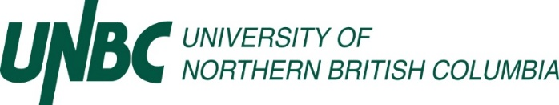
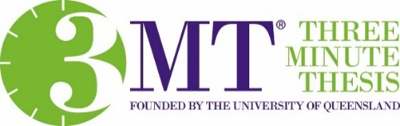
Three Minute Thesis (3MT®) Participant & Supervisor Support Form

Dear Graduate Participant & Supervisor,

Graduate student (insert name) wishes to register for the Three Minute Thesis (3MT®) competition scheduled for Thursday, March 7th, 2024, from 1:30-3:30pm in the Bentley Centre (7-172), UNBC Prince George Campus.

3MT® is a university-wide competition for UNBC Masters and PhD students in which participants present the main idea of their research in 3 minutes or less to a panel of non-specialist judges. The challenge is to present complex research material in an engaging, compelling way, using only one static slide.

As per our requirements to compete, we need to confirm with you that this student is eligible to compete, and presenting does not compromise the student’s research in relation to confidentiality & intellectual property (see descriptions below).

Eligibility
- To participate in 3MT® 2023, you must currently be registered in a Master’s (thesis or research project) or PhD program at UNBC.
- Students registered in degree programs that are strictly course-based are not eligible.
- Each participant must submit this completed Form no later than Thursday, February 22th, 2024, to lucas.rigamontbraganca@unbc.ca, confirming that they have completed substantial progress in research and analysis of their research topic.
- Students that have successfully defended their thesis but have not yet graduated are eligible. Students must not have graduated prior to March 2024.
- Each participant must consent to have their 3MT® presentation video recorded and shared with the other participants, as well as have the presentation posted online.
- Presentations must be based on research that is directly related to the student’s graduate research.
- Students that participated in previous 3MT® competitions are eligible to participate again, but their presentation must be new for 2024.
- Presenters must attend the event to give their live 3MT® presentation on Thursday, March 7th, 2024, from 1:30-3:30pm in the Bentley Centre (7-172), UNBC Prince George Campus.
- To advance in the competition, winners must also be available to present at the Western Regional Finals (date and location TBD).
- Presenters must submit their final slide and title of their presentation no later than Monday, February 26th, 2023, via email to lucas.rigamontbraganca@unbc.ca, following these guidelines:
- A single static PowerPoint slide is permitted (no slide transitions, animations or 'movement' of
any description, the slide is to be presented from the beginning of the oration).
- PowerPoint slide should be created using an aspect ratio of 16:9.
- No additional electronic media (e.g. sound and video files) are permitted.

Confidentiality and Intellectual Property Guidelines
- The 3MT® presentation must represent the thesis research of the presenter only.

The presentation of the research, will not affect any pre-existing rights regarding its use at all times, prior to, and following the competition except as stated below:
- Due to the nature of the competition, judges, reviewers, staff, or the audience will not be asked to sign non-disclosure statements.
- If your research is being/has been conducted under contract with an outside sponsor, please discuss the related contractual terms of confidentiality and intellectual property with your supervisor before presenting your research project.
- All public sessions of the competition, including but not limited to oral presentations, are open to the public at large; all these public sessions will be broadcast to interested people through virtual media.
- Any data or information presented or divulged in public sessions should be considered in the public domain.
- If your research includes confidential or culturally sensitive material, you should think very carefully about how you can present this information. We advise that you discuss your competition entry with your supervisor(s) before entering the 3MT®.

Student Information:
Full Legal Student Name:
Student UNBC Email Address:
Mailing Address:
Department/School of Study:
Program of Study (e.g. MSc, MA, PhD):
Year of Study:
Title of Presentation (tentative title acceptable):

Supervisor Information:
Please confirm your student’s eligibility.

Supervisor’s Name:

I confirm that the student is eligible and that their participation in the 3MT competition will not compromise their research confidentiality or intellectual integrity.

YES NO

__________________________________________ _______________________________
Signature Date

