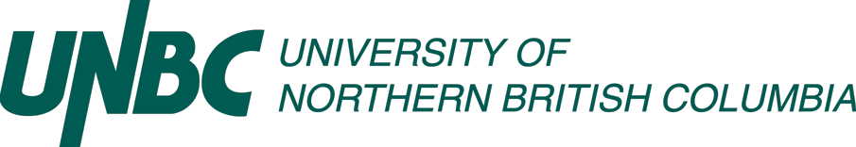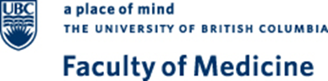

Northern Pathways to Medicine Program (NP2M)

Program Overview

Despite efforts at the level of medical school Admissions to increase the diversity of MD students, under-representation from indigenous, rural and socio-economically disadvantaged backgrounds, remains a concern. To help meet its obligations as a socially responsible medical school, the Northern Medical Program (NMP), as a distributed site of the UBC MD Undergraduate Program (MDUP) delivered in partnership with the University of Northern BC (UNBC), is developing innovative ways of increasing enrollment from these groups.

The NMP has developed the Northern Pathways to Medicine Program (NP2M) for eligible students from under-represented populations whose long-term goal is admission to UBC’s MDUP at the NMP. The program consists of three main elements which aim to support the recipient to be competitive for application to medical school: 1) a longitudinal pre-medical enrichment program alongside their undergraduate degree, 2) formal mentorship from faculty of the NMP and UNBC, and 3) financial support.

Funding for this program is provided by the Northern Medical Programs Trust (NMPT) to support three students per year for the duration of a four-year program at UNBC. The NP2M aligns with the aims of the NMPT, the social accountability and equity mandates of the UBC Faculty of Medicine and the vision, mission and values of UNBC.

Northern Pathways Program Design

The NP2M Program will include the following elements:
- A bursary up to a maximum of $10,000 per year, for the duration of the participants undergraduate degree (yearly renewal required)
- Identification of a faculty member in the NMP or UNBC to act in a mentorship role
- Access to Medical College Admission Test (MCAT) prep and mock MCAT tests
- A paid summer student research experience within the NMP or UNBC during the summer after third year
- Assistance from program staff in accessing the financial aid office at UNBC
- Participation in an enrichment program throughout the duration of the undergraduate degree
- Guidance and direction for appropriate volunteer activities
- Academic advising and support
- Support in building the recipient’s application profile over the 4 years and providing them with the tools to meet criteria for MD program admission.
- Guidance through the MD program application process, including interview preparation.

Eligibility Criteria

NP2M Program is restricted to residents of British Columbia from North Central Local Government Association (NCLGA) communities who have successfully applied to and registered in an undergraduate degree program at the UNBC.

Applicants must come from a socially and/or financially disadvantaged background. This will be determined by the NP2M Steering Committee using BC loans financial aid guidelines, and through consultation with the UNBC Awards and Financial Aid office.

The program particularly welcomes applications from Indigenous Peoples

Participant Selection

Applications will be reviewed through a 2-stage process by members of the NP2M Steering Committee and shortlisted based on two criteria:

- Fit with the vision and eligibility criteria of the NP2M Program
- Evidence of strong academic ability

Shortlisted applicants will be invited to an onsite interview (funding for travel provided). Video conference interviews may be made available to applicants for whom travel to Prince George is prohibitive.

Final offers will be made based on combined evaluation of pre-interview files and interviews.

Progression in the NP2M Program
Continuing participation in the program will be dependent upon scholars meeting the following criteria at annual review:
- A minimum annual GPA of 3.33 or at the discretion of the steering committee.
- Participation in at least 75% of the NP2M enrichment program for the academic year.
- Participation in biannual progress meetings with the Program Director or designate.
- Participation in volunteer activities.
- Enrollment in a full course load, defined as 24-30 credits per year.

Application to the MD Program

During the third or final year of their undergraduate program, participants will ordinarily be expected to apply to the NMP site of the UBC MD program.

