VMWare at UNBC is changing as of August 13th, 2018

VMWare (Virtual Desktop environment or VDI) has been upgraded to new Servers and Pools
- New server – desktop.unbc.ca
- Old servers – view.unbc.ca & secureview.unbc.ca. DO NOT USE AS OF Monday August 13th
Existing Client Install
Please use the following steps to upgrade your existing VMWare client. To start a New Client Install see page 2
  - Upgrade your client if necessary. You should be at v4.0.8 or higher
  - See New Client Install section for client download steps.
  - Software update Notifications are located under ? (Help) located upper right corner
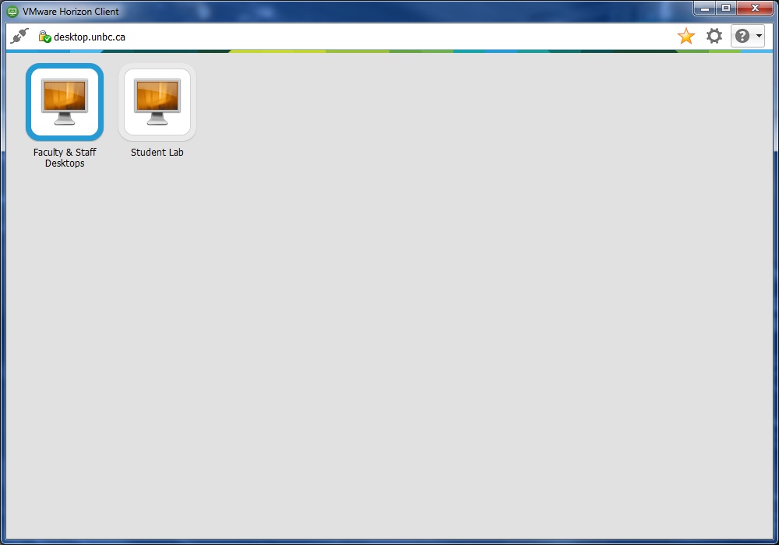
  - Right Click and Delete secure.unbc.ca & view.unbc.ca – do not use anymore!!
  - Click on + New Server to add desktop.unbc.ca
  - Connect and use the Pools you have access to
  - All VMWare Pools are now Windows 10
  - Your UNBC Username & Password are the credentials to use on login
  - New Features – the VMWare Client will notify you when a new version of the client is required.

- New Client Install
  - To start the install please visit desktop.unbc.ca
  - Click on Install VMWare Horizon Client
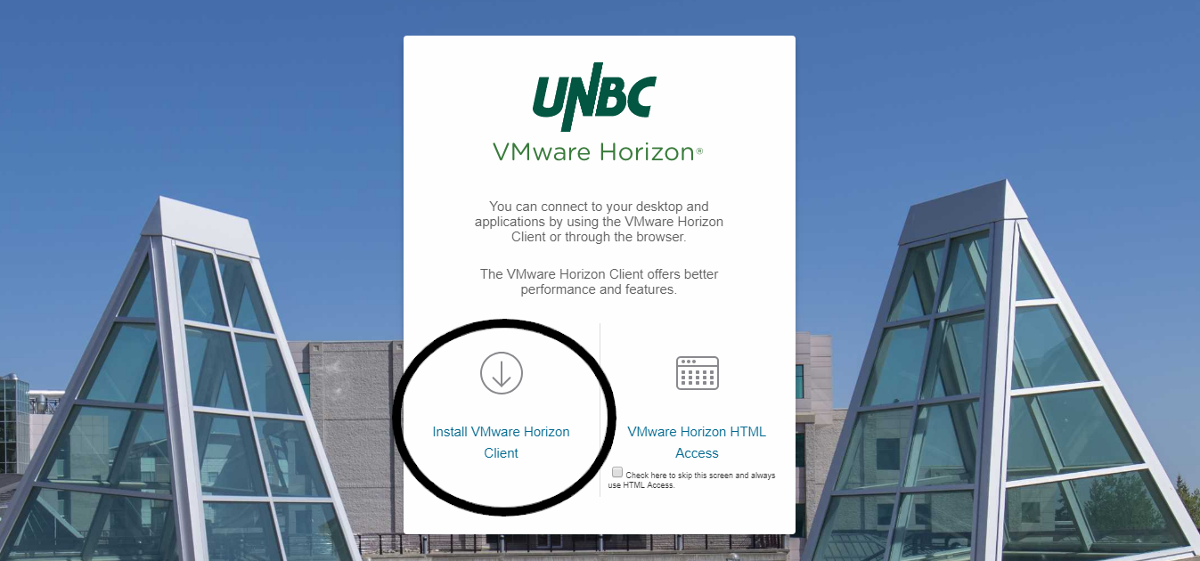
  - You will be redirected to the official VMWare site
  - Choose the client appropriate for you Operating System
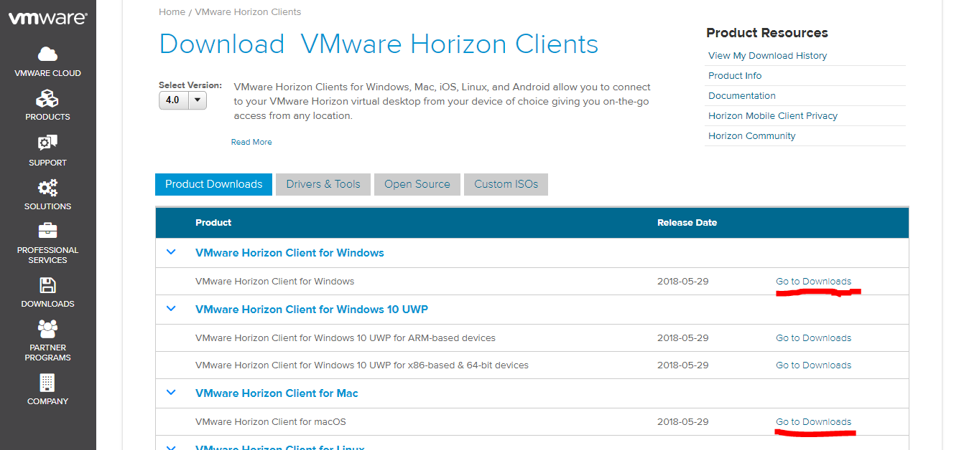

  - Windows Users - choose VMWare Horizon Client for Windows and click on Go to Downloads, Click on Download
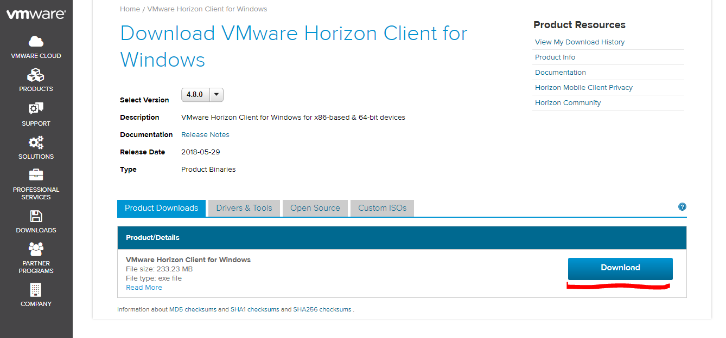
  - MAC Users - choose VMWare Horizon Client for Mac and Go to Downloads, Click on Download
  - The download will start and be visible in your downloads folder or on your browser task bar
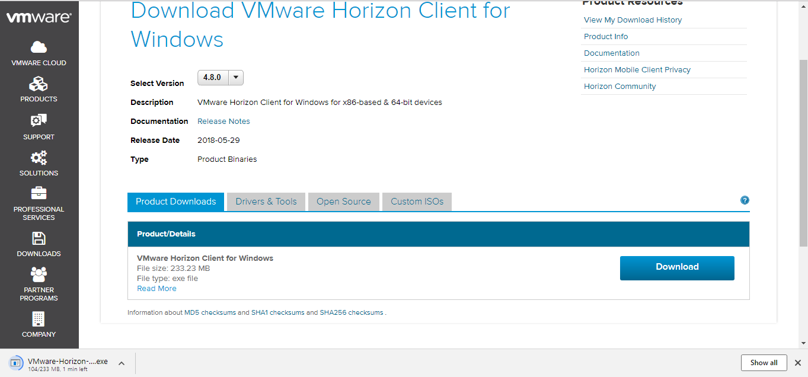

- Click on Install file located on your browser or downloads folder
- Click on Agree & Install
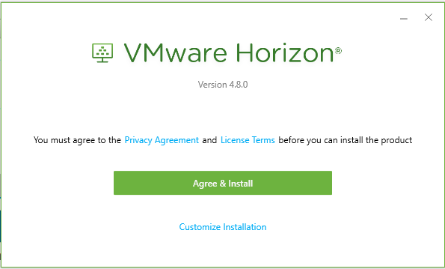
- Wait for the install to finish
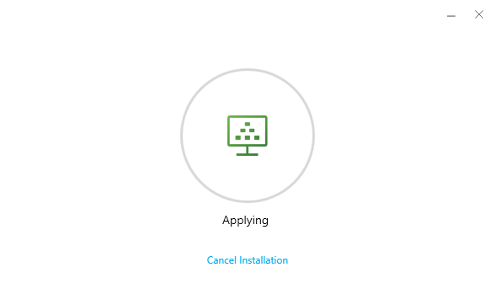

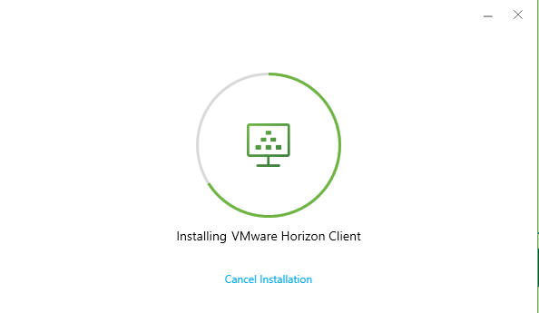

- Install is Finished
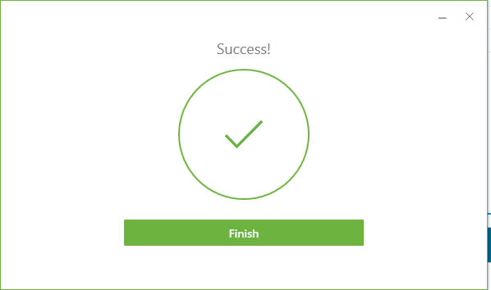

- Restart your System
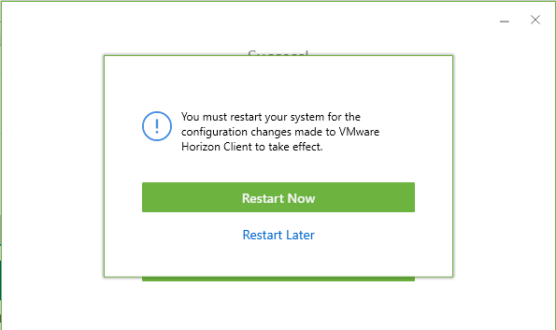
- Your Desktop will have a new VMWare shortcut after restart
- Click on the shortcut to finish the new client setup
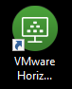

- Server - desktop.unbc.ca is already entered for you
- Click on desktop.unbc.ca
- Enter your UNBC credentials
- Domain is always UNI
- Click on Login

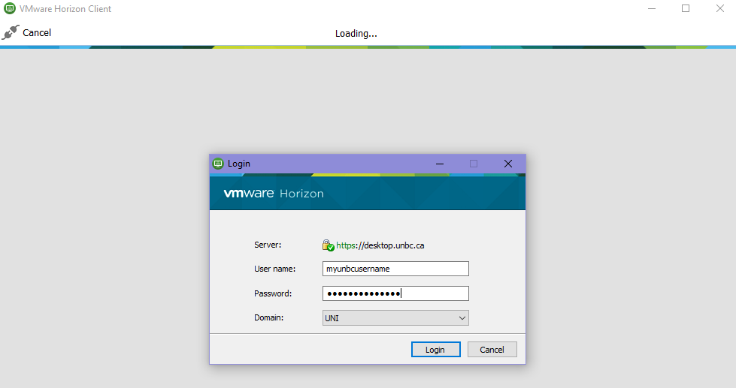

- You will see the Pools you have access to
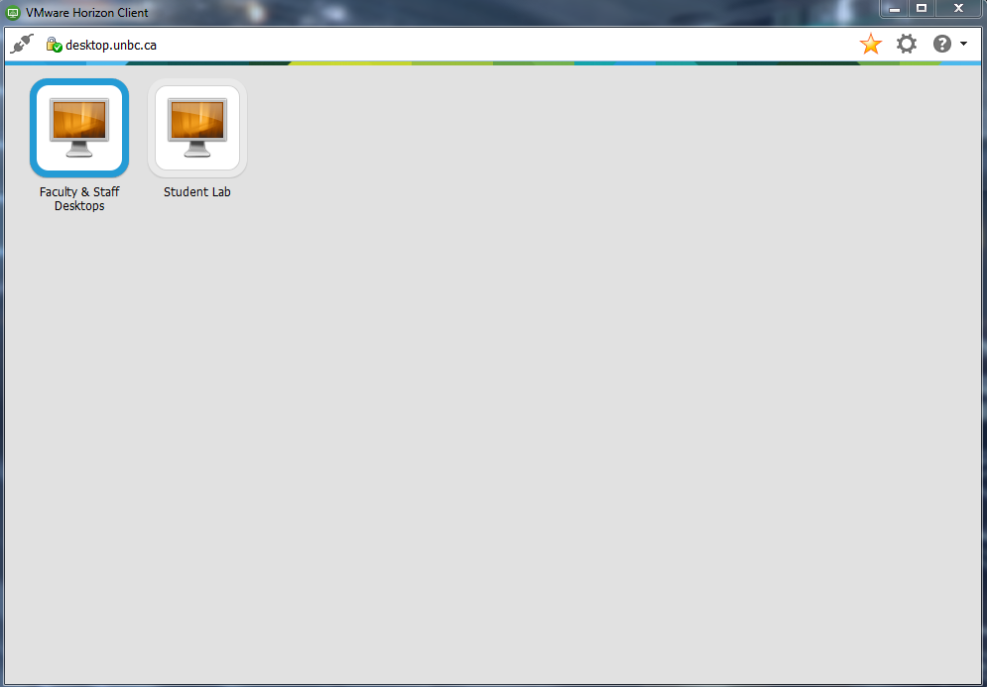
Customization can be done at this point

- Click on the Options Gear Icon
- Choose the Pool you want to customize
- Set Display to Full Screen. This will allow you to use VMWare on one monitor and everything else on a second monitor
- Click on Apply
- Click on OK
- Pools are now setup the way you would like
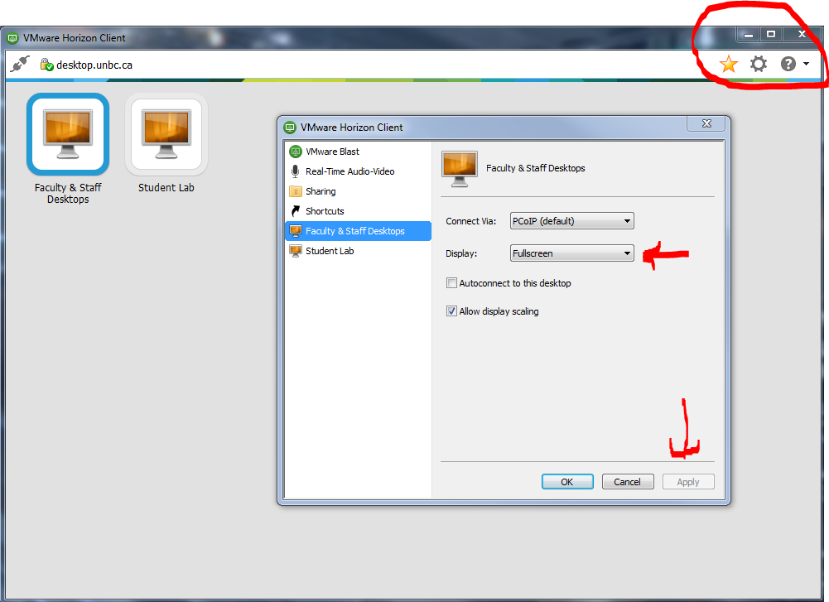
- Choose the Pool you require
- Login using your UNBC credentials
- Domain is always UNI
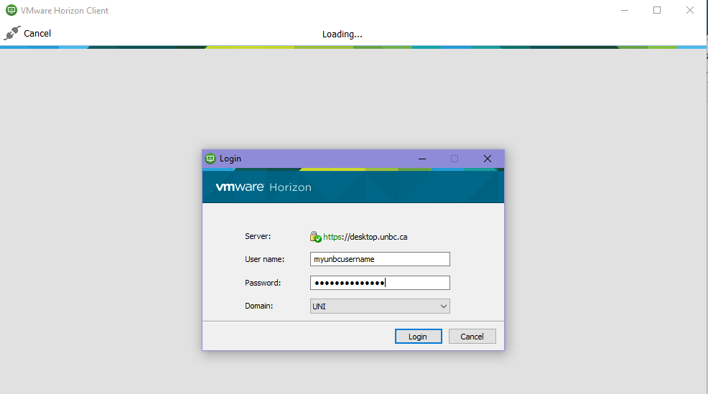
- Click on Allow if you require access to files that are located on your local computer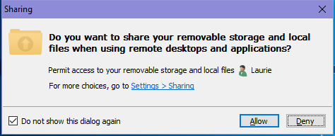

You are now able to fully access UNBC resources and files through VMWare
- Office Products – Word, Excel etc.
- UNBC Licensed Software for Students & Employees
- Resources such as S, G: & H: drives
- Access to websites that are only available on campus such as our support system Cherwell or FAST Grade entry
Important Notes
- All Pools will disconnect after 60 minutes of inactivity
- When you connect again your session will resume where you left off
- There are different behaviours when Logging Off or Disconnecting
- To Log Off click Send Ctrl-Alt-Delete to active the sign Out screen
- Click on Sign Out
- To Disconnect click on the X to the right of the Pool Name
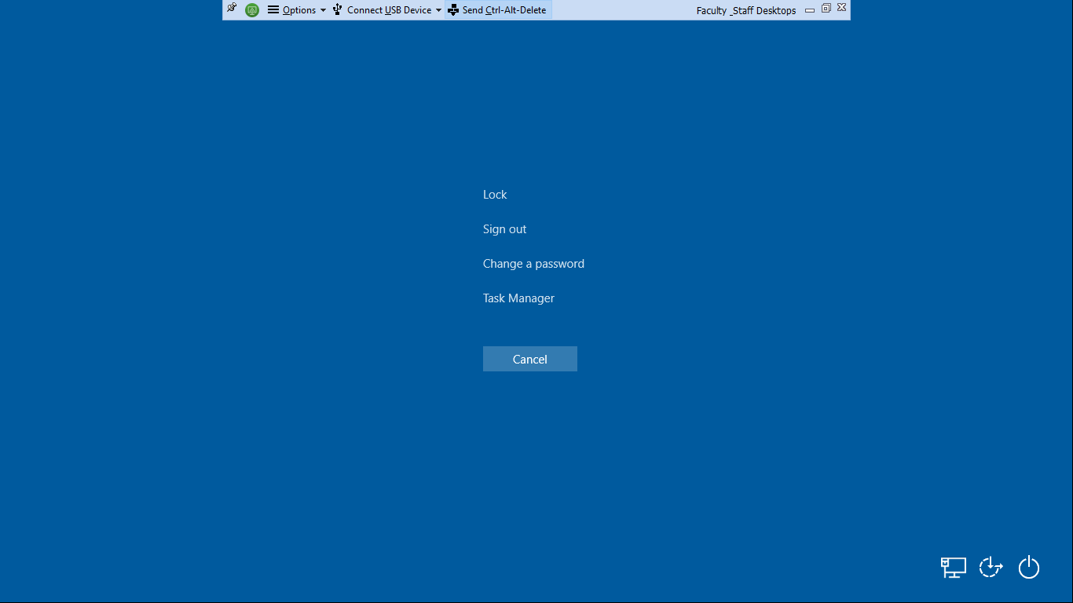

- Click OK to Disconnect completely
