Dahne Harding

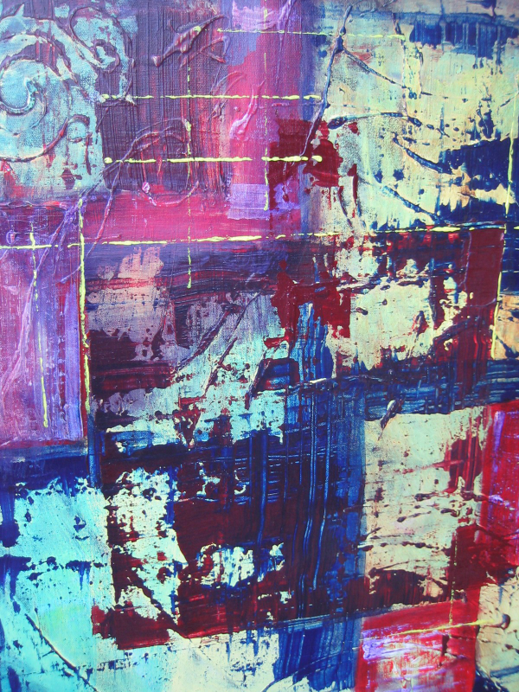

Myths and Memories
24 in x 48 in
Acrylic on canvas

Prince George and the surrounding landscape are inscribed with history. Pictographs and train tracks, burners and culturally modified trees, clear cuts and cultural artifacts that continually remind us how humans engage with the landscape in different ways through time. Temporal and spatial perceptions of the landscape and our relationship to it change with the needs and priorities of the dominant culture, the repercussions of which may be positive or negative depending on the level of care and priorities of our time.

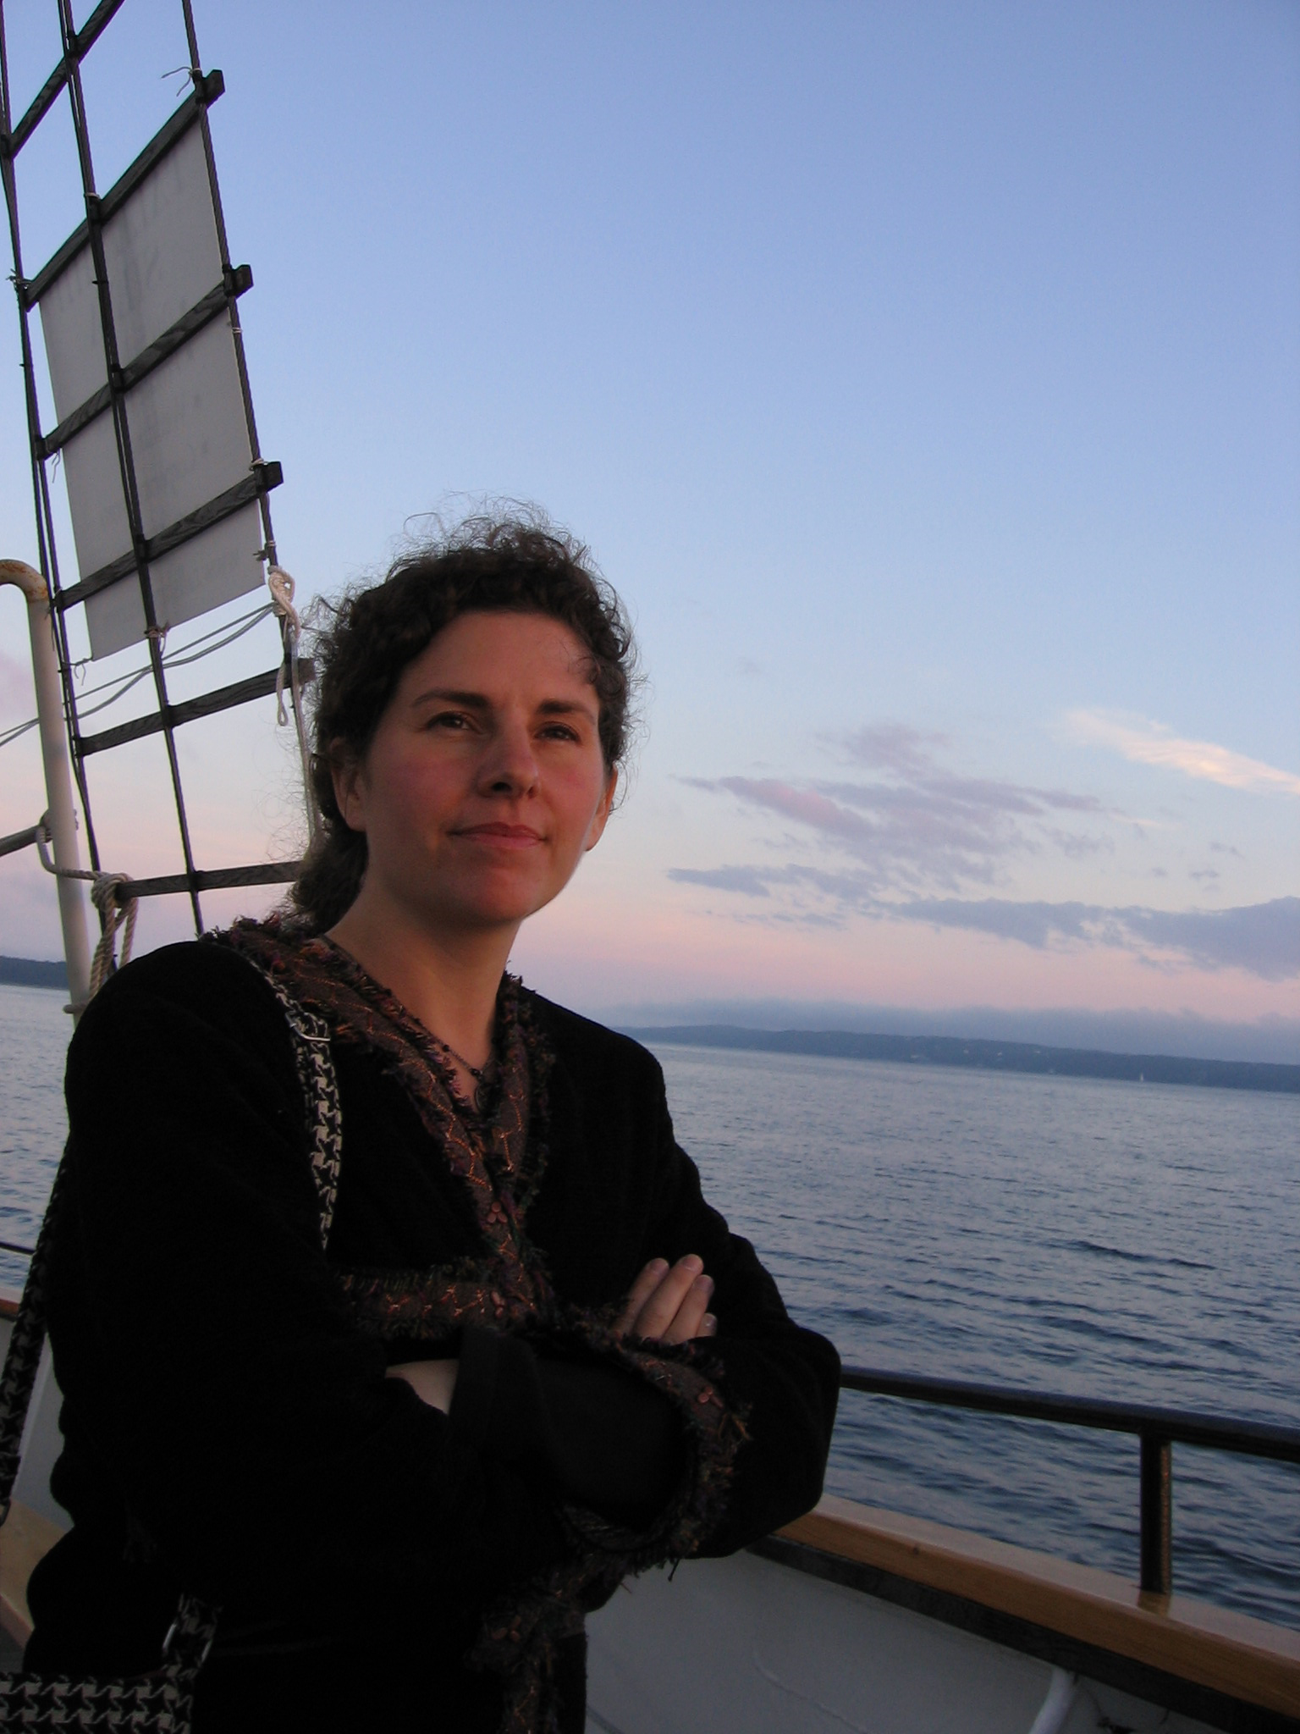
Dahne Harding is a mother, an artist, and a feminist social justice activist who lives and works in Prince George and has been painting and exhibiting her work in Prince George and across Canada for ten years. She has taught in the Fine Art program at the College of New Caledonia and is an arts-based community researcher implementing programming at AWAC, a women’s emergency shelter on George Street. Dahne is currently a candidate for a Master of Arts (Gender Studies) degree at UNBC. Her thesis is titled, “Voices and Visions: Art as an Alternative Voice for Subaltern Women”. The work is based on the idea that
visual art can be an effective platform for women (and men) who are marginalized by multiple social factors to participate in dialogues about community development and to theorize about the structural oppressions that shape their daily lives.

