Annerose Georgeson

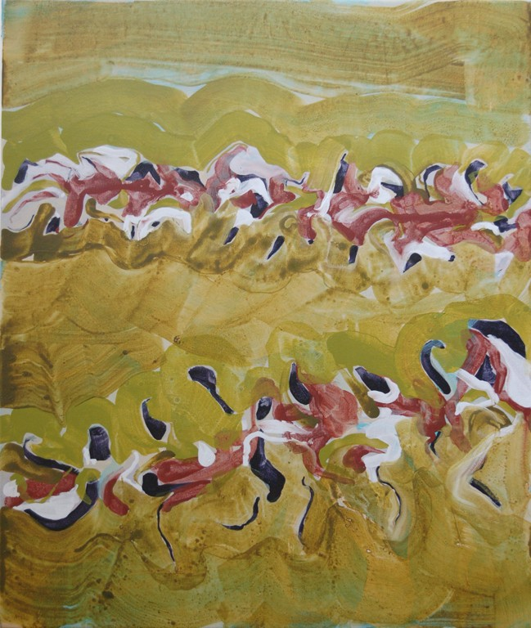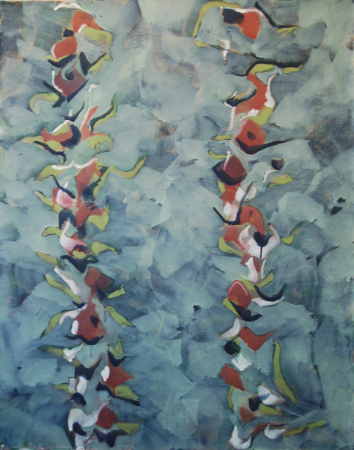

Pine Twigs # 1 Pine Twigs # 2

Acrylic on canvas Acrylic on canvas
20 in x 16 in 36 in x 29 in

Global warming is changing landscapes all over the world. It has certainly changed mine. I used to live in the middle of a pine forest and now I live in a clear-cut. Some parts of the world are losing their glaciers; in the central interior of BC we lost our forest. Our land is now covered by hundreds of miles of dead trees.

But the little trees are growing back.

Bio
Annerose Georgeson makes acrylic paintings and mixed media drawings based
on imagery from nature. She has a BFA from UVic and has had many solo
shows. She was the curator of the Red & Blue Beetle Art, a regional touring
exhibition about the impact of the mountain pine beetle. Georgeson was born
in Switzerland, and as a child immigrated to Canada with her family. She
lives on the same piece of land where she grew up, near Vanderhoof.

