Andrea Pastershank

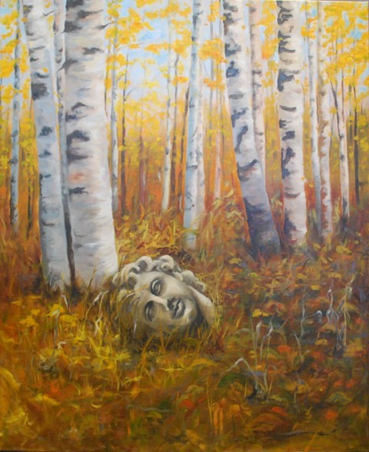

Temple Site
30 in x 40 in
Oil on canvas

The landscape of the Prince George area has a subtle beauty. The extensive trail system that we have access to allow us to be part of the amazing space that surrounds us. I have tried in my work, to convey this sense of beauty and tranquility that I experience every time I head out on the trails.

I was born and raised in Saskatchewan, where I also received my Bachelor of Science in Physical Therapy. I am presently working as a paediatric physiotherapist at the Child Development Centre in Prince George, BC, where I’ve lived with my husband and two children since 1991. I am currently in my second year of studies at the Emily Carr University (UNBC and online). Previous to this I’ve attended many intensive workshops in Western Canada, and in Seattle, Washington. I am an Active Member of the Federation of Canadian Artists. I enjoy the work of creating art and balancing it with the rest of my life roles as wife, mother, physiotherapist and athlete.

