Judith DesBrisay

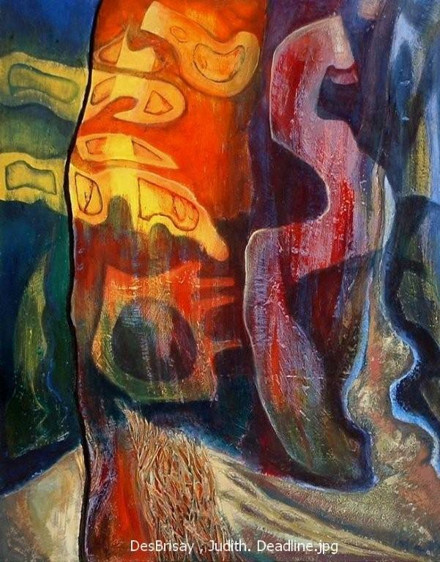

Dead line
Mixed media
30 in x 24 in

The beauty, benefits and concerns inherent in living close to the natural world crystallize at our remote home in Central British Columbia. Among its many attributes this wild haven provides solace for my spirit and materials for my mixed media art works.

“Dead line” is composed of gathered desiccated pine needles, ashes from pine logs burned to warm our home, earth collected on site and shaped upon plaster upon board. Mark making and layers of pigmented glazes and washes unify my impression of a changing world.

“Dead line” is a cautionary tale. The towering pine symbolizes many changes evident in our wilderness surround. We are affected by human and non-human activity: even at a distance. We must participate in the shared responsibility of ensuring positive change for our endangered planet.

At her wilderness home in central British Columbia, DesBrisay notes the interrelationship of persons with their natural settings. Her life, work and travels range from Nunavut and Greenland to Antarctica, including three years experience in South America. DesBrisay‘s art exhibits in Canada and Chile acknowledge life’s inextricably interwoven entities.

