Jean Brandel

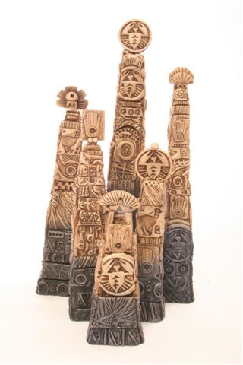

Kenwood Guardians
8 in x 8 in x 8 in

I was raised in the Connaught neighbourhood filled with immigrant and Aboriginal families that struggled economically just to meet day-to-day needs. There often was no money for luxuries such as dancing lessons so we created our own games, inclusive of all neighbourhood children. My most vivid image of a childhood game is playing hide and seek amongst the dahlias in our neighbour’s backyard. Like those hale and hardy plants holding fast onto the soil, my sense of learned values that I received from my youth hold on for survival. I hope for a better future regardless of intolerance of race, class, religion, status, and power in society, as it exists today and its consequences. I have experienced that understanding people helps wash away intolerance and that the best relationships develop with people not because of their wealth or social standing, but because you enjoy being with them and that they treat you like you treat them.

I have always been a non-traditionalist at heart; freedom and innovation are the most important elements in my approach to making art. This helps fulfill my desire to be different. I like to work intuitively, and show that contemporary art can be a visually exciting experience for both the artist and the viewer.

