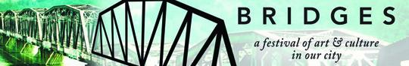

Rotunda Gallery
Inaugural juried exhibit 2009

This exhibition features some of our regions most well-known and emerging artists. These works show the many ways to investigate notions of home and sense of place. A wide variety of materials and concepts convey location from a multitude of perspectives; within the interior landscape of our own minds to vast mountain expanses; quiet fields, forests and home portray serenity and safety; and ultimately, we can find ourselves within our own culture in a way that crosses time and space and returns us to a more clear sense of who we are. These portraits of home reference the relationship we have with our environment and community around Prince George.

This fabulous show is a result of the generosity of the artists who loaned us their works for these few short days; the incredible UNBC facilities staff who installed the show; security staff who installed cameras and became the gallery’s first and most frequent visitors; the UNBC Arts council who will be taking on the formal aspects of managing the space; and the Community Development Institute for its funding and initiatives for establishing projects like this. We would also like to acknowledge the volunteer hours from the jurors and curatorial team that made this show such a success.

Thank you for joining us in celebrating UNBC’s and Prince George’s newest gallery space.

