Ute Wilder

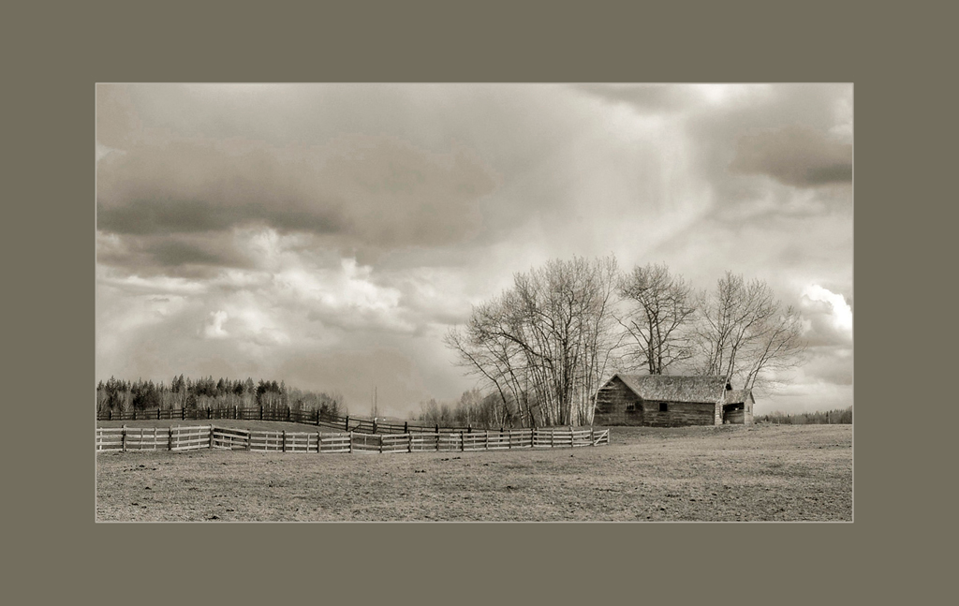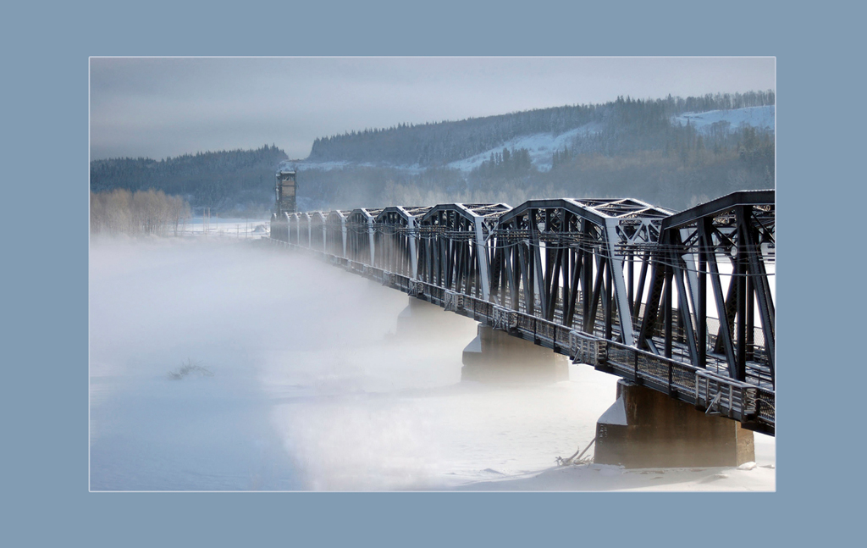

Old Barn Frozen in Time
Photograph on watercolour paper Photograph on watercolour paper
11 in x 17 in 13 in x 19 in

This image shows the big trees protecting the barn from the storm. We have to preserve history and understand where we come from in order to find our place in the future.

The old traditional train bridge is still being used today, and so brings history into our daily lives.

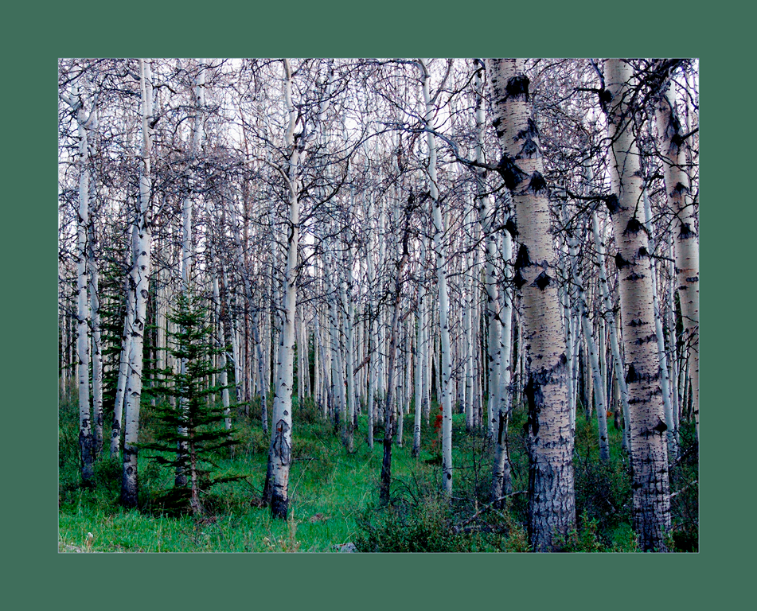
Changing Forest
Photograph on watercolour paper
11 in x 14 in

As the aspen die, more light reaches the forest floor and new grass, flowers and spruce trees can grow. This forest bridges from one species to another

Wilder is a Nature Photographer who studied Photography at SAIT [Southern Alberta Institute of Technology] in Calgary in 2001 and 2002. She was accepted with professional Photographers of BC [PPABC] and Canada [PPOC] in 2007 and has since received national accreditation in Botanical and Pictorial/Scenic Photography. Her images have been accepted at provincial and national competitions. She has been living in Prince George since 2003.

“I love the Area with its diverse wildlife, birds and flowers. I enjoy the outdoors and hope to have more opportunities to photograph nature and show how beautiful our world is.”

