Phil Morrison

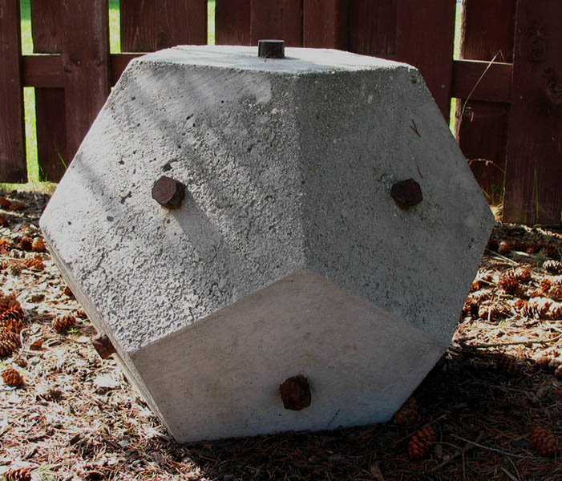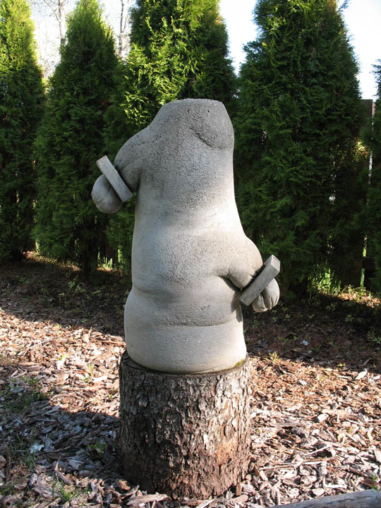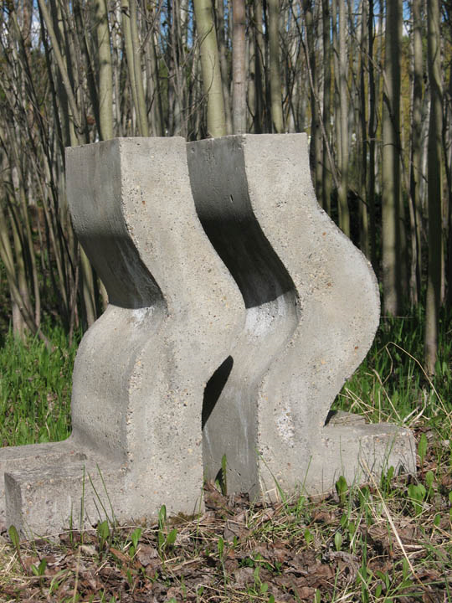
Cut Sphere Desire and Disciple Three Bodies
Concrete and various Concrete and various Concrete and various
24 in x 24 in 36 in x 24 in 36 in x 36 in x 24

Not only geographically
but emotionally and spiritually,
the work of Phil Morrison comes from the Interior.
Born in 1960, he has lived in Prince George all of his life,
making his choice of concrete, rebar and glass
As preferred materials, authentic and poetic.
His works are courageous in their simplicity
and insist on a ruthlessly honest eye
to appreciate their mythical beauty.
They speak to the strength and durability
needed to survive within this landscape.
His sculptures are challenging
by their obviousness.
No fluted columns or distracting ornamentation here,
only the imagination transformed into symbol,
reminding us of the primitive source
that lives at the centre of human experience.
Both masculine and feminine aspects
are well represented: these are the works of a total man,
exploring the truth of his be-ing.
Conflict and communion exist here.
The energy of relationship is released. Harvey Chometsky
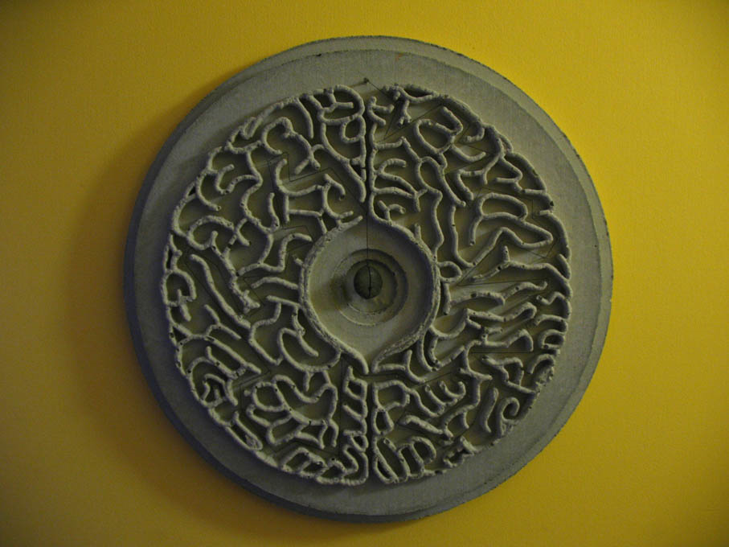
Mandalla, 16 in, Concrete

