David Marchant

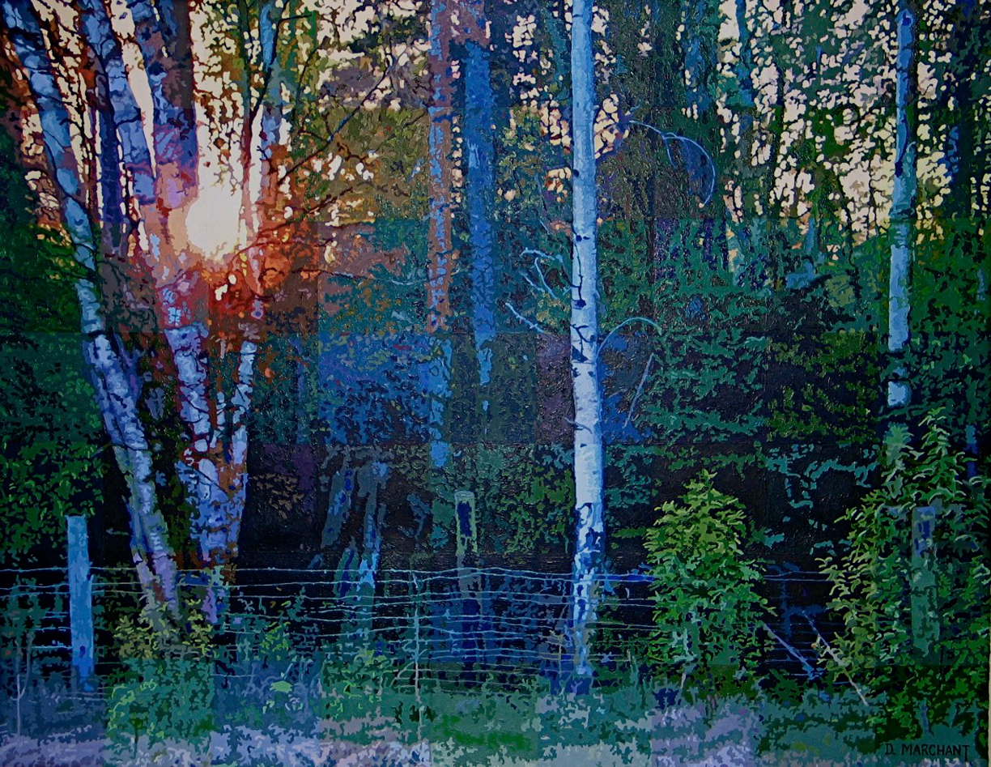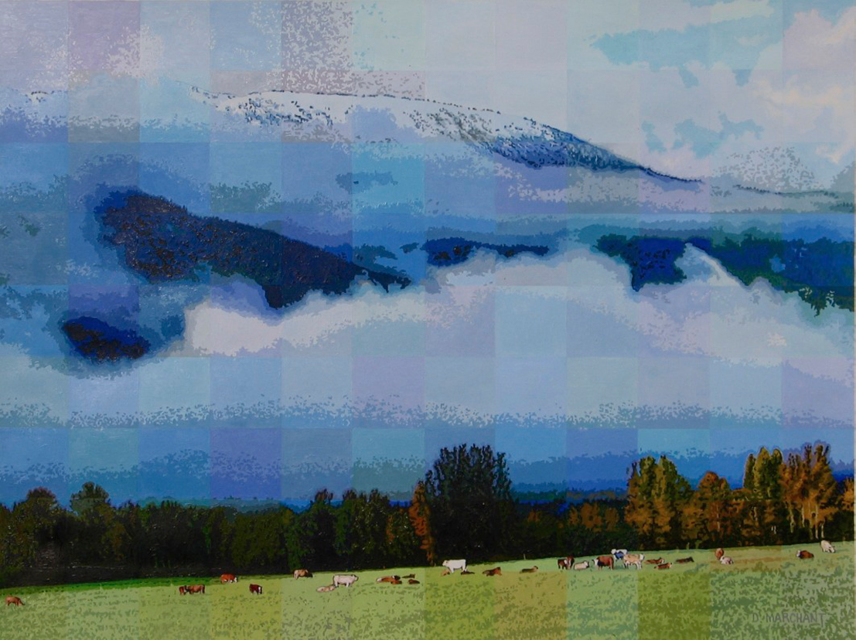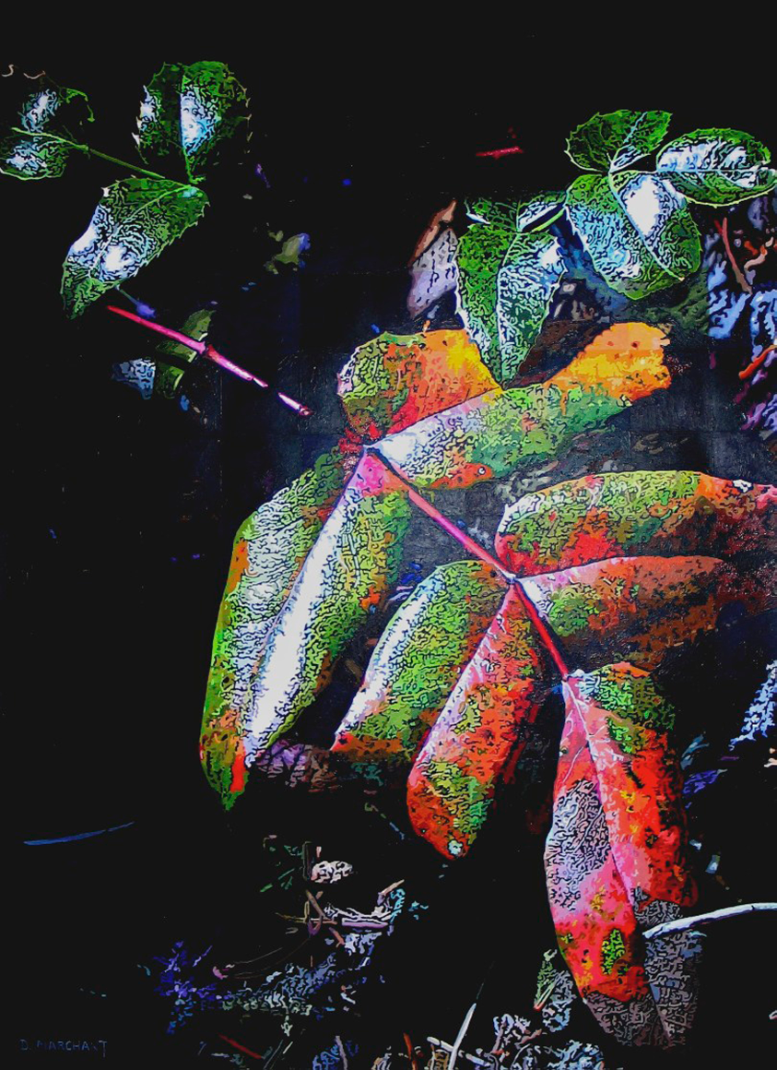

Fence Morning Oregon Grape
Acrylic on paper Acrylic on paper Acrylic on paper
21 in x 27 in 24 in x 18 in 28 in x 20 in

My paintings represent three different realms of Central Interior space. "Oregon Grape" looks down to a world that encompasses less than a metre. "Fence Line" expands our view both in length and width. In "Morning Clouds" our sight line has widened and been elevated to the mountain horizon, and sky beyond.

I was a baby boomer, born and raised in Indiana. I got a degree in elementary education, took Peace Corp training, served two years as a conscientious objector working in a Goodwill Store, immigrated to Canada in 1973, where I taught 3 years in a fly-in one room school on Takla Lake. In 1977, my wife and I bought a place in McBride, and I worked doing mapping for the Forest Service until the government closed out office in 2003. Art had always been important to me, and I dabbled in music, and video, but mostly concentrated on cartooning (I have done cartoons for the local paper for 25 years) and photography (mostly plants and landscape). I came to realize that I was taking photos thinking, "this would be a good image for a painting". In the fall of 2005, I was retired, and it occurred to me that if I didn't start painting soon, I probably never would. So I began. I was totally amazed at how well my first painting (a cabbage) turned out and I felt like I had discovered a talent that I didn't realize I had. I now paint daily. I want to take advantage of the time I have left this late in my life.

