Caroline Lavoie

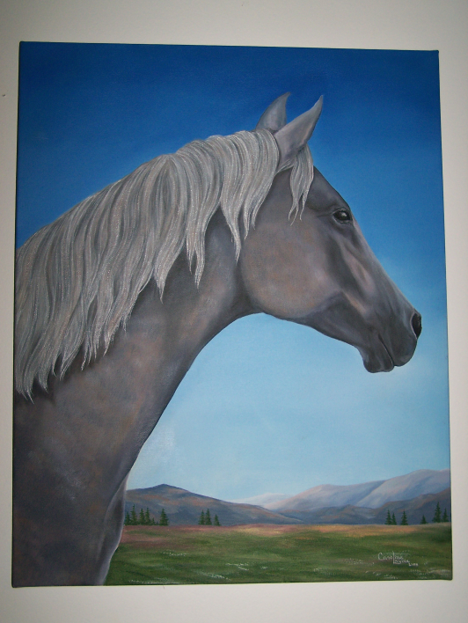

Looking Eastward
Oil on canvas
16 in x 20 in

This is my horse looking towards the McGregor range, at home near Willow River. The East symbolizes for me nostalgia for my native Quebec. However, since each new day begins by the sunrise over the mountains, it also represents a new chapter of my life, in my new homeland, Prince George.

