Shana Labatch

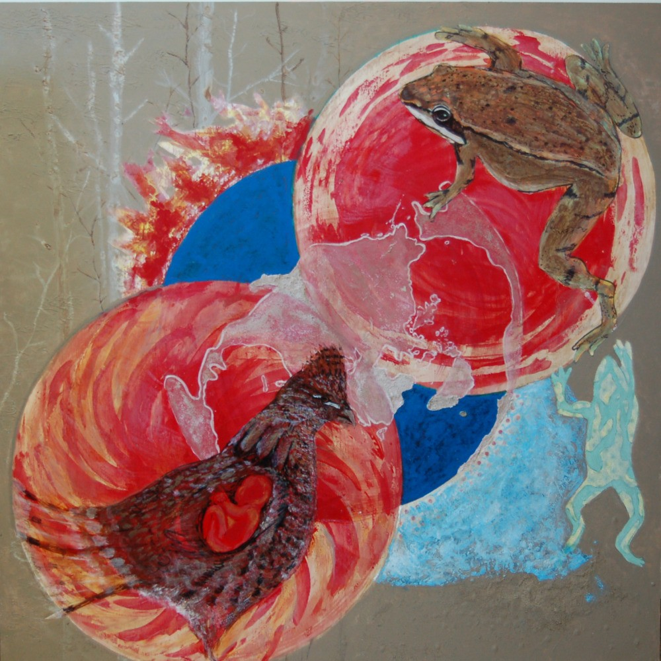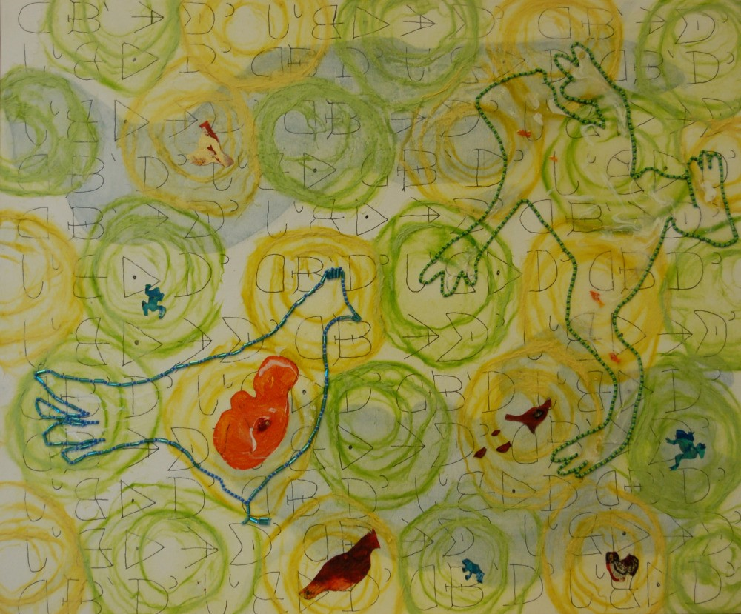

Noolhk'aiwhut'en 'ink'ez Tachekwhut'en Yazyazkhunek"Babytalk"
"Frog and Grouse Clans" Acrylics and mixed media
Plywood, acrylics and mixed media 20 in x 24 in
4 ft x 4 ft

Noolhk'aiwhut'en 'ink'ez Tachekwhut'en
This piece is a commissioned work and on loan from the College of New Caledonia in Vanderhoof. It depicts the surviving clans of Saik'uz Whut'enne but refers, in various ways to the responsibilities and history of our people. We come from the beyond what has been recorded and we are responsible for the people and the waters and the land and all in it. There was a third clan at one time, but a great
catastrophe such as the 1918 influenza epidemic decimated our numbers to the point where the people decided to reduce to only two of the clans. I searched but could not uncover enough of who we are to be satisfied, those details sit like the frog eggs under the "sand" in the piece. There is still hope, however as we are connected to everything that was and will be--we have to be open, and listen. There is a lot here! See what you can discover for yourself.

Yazyazkhunek"Babytalk"

This painting came out of an attempt to speak visually and literarily having been
inspired by "Noolhk'aiwhut'en 'ink'ez Tachekwhut'en". It is also part of an overflow
of the ideas in the former piece. It has revealed itself to relate to nests--perhaps
language, art and culture nests--that we would like to create for ourselves. It is
appropriate that I have such a desire to help build these nests as 'Uts'ut dusdoh",
I am Grouse Clan. It is our clan's responsibility to care for the hearts of the people. Looking from our own difficult experiences should help us compassionately take care of other babies like ourselves. It is painted in hope and is to be one of
many shared stories.

