Betty Kovacic

Ordinary objects, unusual materials, and unexpected presentations collide in “The Soul of the City.” Like a metaphor for the complex dynamics of our city, each piece signifies aspects of experienced urban life. Sustainability is referenced by the inclusion of x-rays as well as old maps and schematics recycled from CNC. Each facet speaks of transition, growth, a connection to the land and evolving permanence. The x-rays indirectly indicate heritage and cultural diversity. With skin like color, topographical maps elucidate concepts of humanity and a connection with the environment. The vital role played by society and individuals is signified by every element from hand-drawn maps and figures to x-rays. Each piece has the potential to evoke a multitude of experiences and meanings.

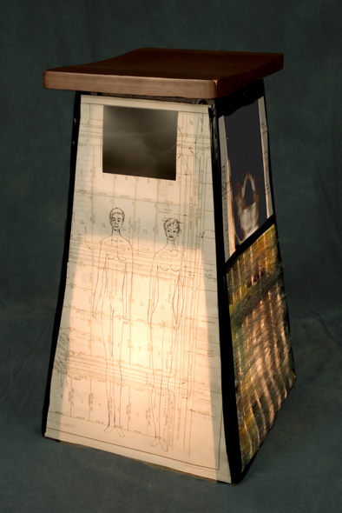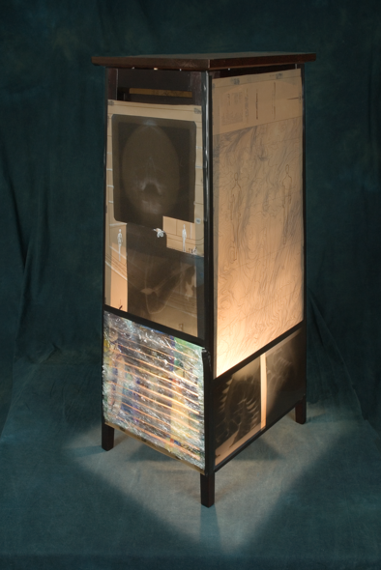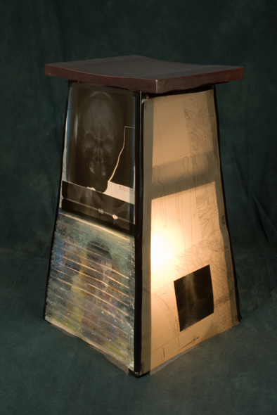

Soul of the City # 1 Soul of the City # 2 Soul of the City # 3
Stool and mixed media Cabinet and mixed media Stool and mixed media
top 11 in x 15 in, top 15 in x 13 in, top 11 in x 15 in,
base 15 in x 15 in base 18 in x 14 in base 15 in x 15 in

Betty Kovacic, who received her BFA from the University of Victoria, is a veteran of numerous solo shows and exhibitions. Her interest in the human condition informs her art. For six years Betty focused on the multitude of issues surrounding the Missing Women of British Columbia. Recently, after experiencing Operas such as “Tristan and Isolde”, she began to explore myths of metaphysical love. Betty received acclaim since the 1980’s: her art was consistently selected for the prestigious B.C. exhibitions Images and Objects. Her projects have received recognition from the Integris Credit Union, British Columbia 2000 Community Spirit, the Historica Foundation, the B.C. Interior, North and Yukon’s Today’s Women Award, the Leon and Thea Koerner Foundation, the Hamber Foundation, and the Vancouver Foundation.

Her work can be found in numerous public, corporate and private collections. She is represented by the Tu Gallery in Edmonton, Alberta. Betty has been teaching in the CNC
Fine Art program for 9 years.

