Project Title
- Partners/Audiences  See next page for Segmenting Partners. Not all partners play the same role. | 1a. Stakeholders (who are you listening to): list the organizations and individuals who will share their stories and experiences to tell you what they think is important and to find out goals that are meaningful to them. You might engage with them at the beginning or throughout the research.  1b. Co-production partners (who are you collaborating with): List the individuals and organizations that will work with you as co-researchers or as stakeholders providing on going input throughout the research.  1c. Audiences/Receptors (who are you disseminating to): List These are the individuals and organizations who aren’t working with you but want to receive the results of your research.
- Goals: flip the problem  Should be consistent with your research goals. | Should be co-constructed with your Partners/Audiences (#1) to be meaningful to them as well as to academic researchers. If you are researching access to fresh produce in a low income food desert then your problem might be “lack of access to fresh produce” and your long term goal might be “enhance access to fresh produce” and a short term goal might be “generate decision tools and incentives for produce providers”.
- Activities: what activities will you do with those in #2 | 3a. Stakeholders (what will you do to listen to them): these are activities that allow you to capture the input and goals of stakeholders. Will you use town hall meetings, one on one interviews, social media etc? Will you budget for parking, baby sitting, food?  3b. Co-production partners (what will you do to collaborate with them): How will you co-produce research? Will a partner be a co-researcher involved in setting the agenda, data collection and analysis, writing reports? Or will the provide specific input at specific points in the research? Will they be compensated for their time?  3c, 3d. Audiences/Receptors (what will you do to disseminate to them): How will you get the right information (what is it) to the right people (who are they) at the right time (ie do you need to hit a “policy window”) in the right format (which one: policy brief, social media, infographic) to inform decisions? Think about engaging forms of dissemination including arts-based methods and facilitated workshops with end users.
- Impact: Describe the future state if you achieve your goals | What does the future look like it you complete the actions (3) to address the goals (2) with your stakeholders (1)? Will you reduce teenage pregnancy? Will you get take up of your culturally appropriate family planning information?
- Evidence of Impact: Qualitative and quantitative data, data sources, when to collect data | - What changes and for whom?  - How will you know?  - How can you prove it (i.e., what evidence do you have)? What data will you need; do you have access to those data; do you collect data at the end or throughout  - How will you record it? What will you do to communicate the impact?
- Budget/Resources for activities | Impact is not a 10 hour/week undergraduate student. These are real people doing real work. Pay them a living wage. Compensate your co-production partners. Don’t forget about translation if engaging with stakeholders who’s first language isn’t English. Budget for designers for infographics, videographers etc. Ask your stakeholders what they need to meaningfully engage with you and fund those expenses (food, parking, child/elder care). Culturally appropriate gifts for Indigenous participants.

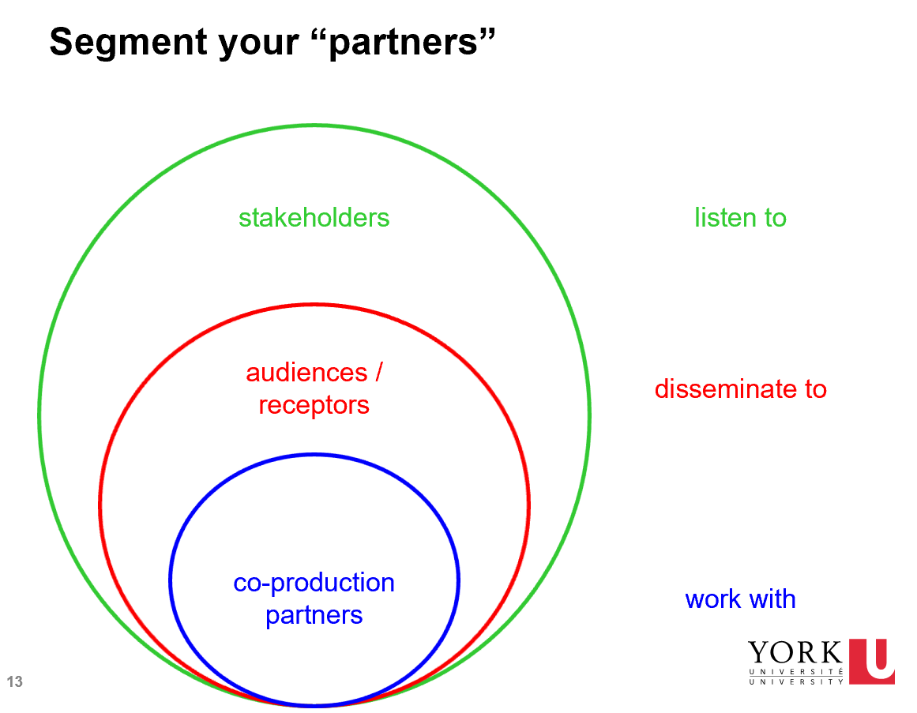

Project Title
- Partners/Audiences | 1a. Stakeholders (who are you listening to):  1b. Co-production partners (who are you collaborating with):  1c. Audiences/Receptors (who are you disseminating to):
- Goals: flip the problem
- Activities: what activities will you do with those in #2 | 3a. Stakeholders (what will you do to listen to them):  3b. Co-production partners (what will you do to collaborate with them):  3c, 3d. Audiences/Receptors (what will you do to disseminate to them):
- Impact: Describe the future state if you achieve your goals
- Evidence of Impact: Qualitative and quantitative data, data sources, when to collect data | - What changes and for whom?  - How will you know?  - How can you prove it (ie what evidence do you have)?  - How will you record it?
- Budget/Resources for activities
RESEARCH IMPACT PLAN TEMPLATE

Flip the problem: If you are researching access to fresh produce in a low income food desert then your problem might be “lack of access to fresh produce” and your long term goal might be “enhance access to fresh produce” and a short term goal might be “generate decision tools and incentives for produce providers”.
Flip the problem: If you are researching access to fresh produce in a low income food desert then your problem might be “lack of access to fresh produce” and your long term goal might be “enhance access to fresh produce” and a short term goal might be “generate decision tools and incentives for produce providers”.

