Michelle Jensen

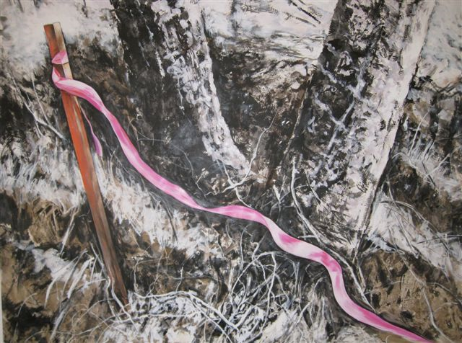

Halt!
Mixed media on paper
37 in x 48 in

A forest city edging on wild- bordering dangerous expectation.
Tempting trespass, one step past the surveyor’s tape and you are drawn into tangled manoeuvres.
Planted firmly in ancestral ground, wooden stake stands tiny-mighty. Catch wind, warn and beckon. Neon line traverses primitive rawness.
Chaotic, benign property line.

Michele Jensen has been a Prince George resident for 6 years. Relocating from the prairies, the trees and forests never fail to fascinate. With a BFA in printmaking and drawing from the University of Alberta, her work is heavily influenced by the process of mark-making and the drawn image. Most of her work is abstract with suggestive representation. The piece ‘Halt’ embraces controlled representation in the neon surveyor’s tape in contrast to the raw expressionistic rendering of the forest setting. In this way, the approach to the subject creates its own dialogue between trunk and stake, and the medium enforces its own boundaries.

